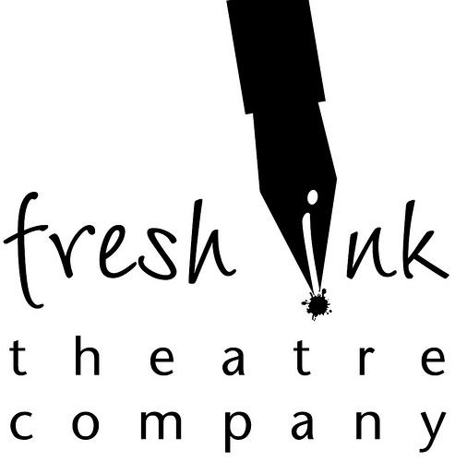FOR IMMEDIATE RELEASE

For all inquiries contact

Amanda Sheehan
Marketing Manager
press@freshinktheatre.com
772.418.5754

(Boston, MA) Fresh Ink Theatre presents Distant Neighbors by Patrick Gabridge, December 5 – 13, 2014 at Boston Playwrights’ Theatre.

Distant Neighbors by Patrick Gabridge
A group of suburban neighbors are strangers to each other until an alien space ship crashes into their back yards. After its arrival, they get to know each other a lot better, and faster, than they ever expected (or wanted). Distant Neighbors is a space-age love story about loneliness and longing, and the barriers we set up between us. It looks at the possibility for wonder, not just at the skies and the universe, but also at the person living right next door.

Patrick Gabridge (Playwright) Patrick’s full-length plays include Flight, Distant Neighbors, Fire on Earth, Constant State of Panic, Blinders, and Reading the Mind of God and have been staged by theatres across the country. His plays are published by Playscripts, Brooklyn Publishers, Heuer, Smith & Kraus, and Original Works Publishers. He’s been a Playwriting Fellow with the Huntington Theatre Company and with New Rep and is a member of the Dramatists Guild and StageSource. Recent commissions include plays and musicals for In Good Company, The Bostonian Society, Central Square Theatre, and Tumblehome Learning. He’s also the author of two novels, Tornado Siren and Moving (a life in boxes). His work for radio has been broadcast and produced by NPR, Shoestring Radio Theatre, Playing on Air, and Icebox Radio Theatre. Patrick has a habit of starting things: he helped start Boston’s Rhombus Playwrights writers’ group, the Chameleon Stage theatre company in Denver, the Bare Bones Theatre company in New York, the publication Market InSight… for Playwrights, and the on-line Playwrights’ Submission Binge. He’s also a member of the Dramatists Guild, StageSource, and a board member of the Theatre Community Benevolent Fund. You can read more about Patrick’s work on his website, www.gabridge.com, or on his blog, The Writing Life x3. Patrick has a passion for history and a lifelong love of science and scientists. In his spare time, he likes to farm.

Info & Tickets
Fresh Ink Theatre: http://freshinktheatre.org
Direct Box Office Link: https://web.ovationtix.com/trs/pr/941007
December 5 – 13, 2014
Wednesday & Thursday at 7:30pm
Fridays at 8:00pm
Saturdays at 3pm & 8pm
Sunday at 3pm

*Post Show Social following the evening performance on December 6th*
*Date Night December 10th - Buy One Ticket Get One Free & a Free Concessions Package*
*Playwright's Night on December 11th with Tootsie Pop Talkback*

$20 General Admission
ALL 3pm performances are $20 online or Pay What You Can at the door
Groups of 8 or more get $5 off!

Boston Playwrights’ Theatre
949 Commonwealth Ave.
Boston, MA 02215

Cast
Adams - Sheldon Brown
Talia - Louise Hamill
Griffin - Daniel Boudreau
Melanie Tomlinson - Gillian Mackay-Smith
Blake - Michael Knowlton

Design Team
Playwright - Patrick Gabridge
Director - Liz Fenstermaker
Dramaturg - Tyler Monroe
Production Manager - Gabe Hughes
Stage Manager - Keagan McCarthy
Lighting Design - Christopher Bocchiaro
Set/Props Design - Marc Ewart
Sound Design - Lindsey Anderson
Costume Design - Bridgette Hayes
Assistant Director - Gabe Graetz
Assistant Stage Manager - Andrew Cataluna

More Information can be found at http://FreshInkTheatre.org/distant-neighbors.html

ABOUT FRESH INK
Fresh Ink Theatre provides an avenue for the development of new work on the Boston small theatre scene in a collaborative, playwright-centered manner. The company was born in the summer of 2011 and debuted at the Factory Theatre the following December with the nearly sold-out run of Priscilla Dreams the Answer by Walt McGough. Fresh Ink's unique submission model and development process have led to successful runs of plays by local playwrights Ginger Lazarus, Patrick Gabridge, Emily Kaye Lazzaro, MJ Kaufman, James McLindon, and Lila Rose Kaplan. Fresh Ink also created the Ink Spot staged reading series as another avenue to showcase new work and the annual Mad Dash 24-hour play festival and Scriptpocalypse. Now, after three seasons as residents of the Factory Theatre, Fresh Ink is excited to bring our work to two new spaces this season -- the Boston Playwrights' Theatre and First Church Boston.

MISSION
Fresh Ink Theatre Company is committed to developing new work with emerging theatre artists in the New England area. We seek to empower writers with the tools to craft plays that showcase their creative vision, and we challenge the Boston community to engage in the evolution of new work as it transforms from first draft to first production, and beyond. We value artistic excellence, institutional transparency, community involvement and ongoing collaboration.

www.freshinktheatre.org
facebook.com/freshinktheatre
twitter.com/freshinktheatre

FRESH INK IS:
Louise Hamill, Artistic Director
Jessie Baxter, Literary Director
Lyndsay Allyn Cox, Managing Director
Amanda Sheehan, Marketing Manager
Gabe Hughes, Production Manager
Cassie Lovering, Community Engagement Coordinator

# # #

